**Project Initialization and Planning Phase**

| Date | 15 July 2024 |
| --- | --- |
| Team ID | team-740084 |
| Project Name | Online Payments Fraud Detection |
| Maximum Marks | 3 Marks |

**Define Problem Statements (Problem Statement Template):**

With the rise of e-commerce and digital transactions, the need for robust security measures to protect against fraudulent activities has become paramount. Online payment fraud not only results in significant financial losses for businesses but also undermines customer trust and confidence in digital payment systems. Therefore, it is crucial to develop effective methods for detecting and preventing fraudulent transactions in real-time.

The objective of this project is to build a machine learning model that can accurately identify potentially fraudulent transactions. This involves analyzing large datasets of transaction records, extracting relevant features, and applying advanced algorithms to distinguish between legitimate and fraudulent activities.

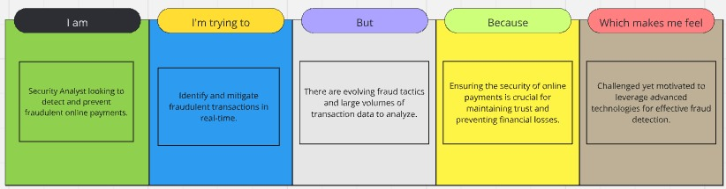

|  |  |  |  |  |  |
| --- | --- | --- | --- | --- | --- |
| **Problem**  **Statement (PS)** | **I am**  **(Customer)** | **I’m trying to** | **But** | **Because** | **Which makes me feel** |
| 1 | A merchant running an online store. | Ensure the security of online transactions. | I can’t accurately detect fraudulent transactions in real-time. | I don’t have a robust fraud detection system in place. | Anxious and worried about potential financial losses and damage to my reputation. |
| 2 | A financial institution offering online payment services. | Protect my customers and reduce fraudulent activities. | I can’t efficiently identify and prevent fraudulent transactions. | I lack advanced tools and techniques for real-time fraud detection. | Concerned about customer trust and the increasing risk of financial fraud. |